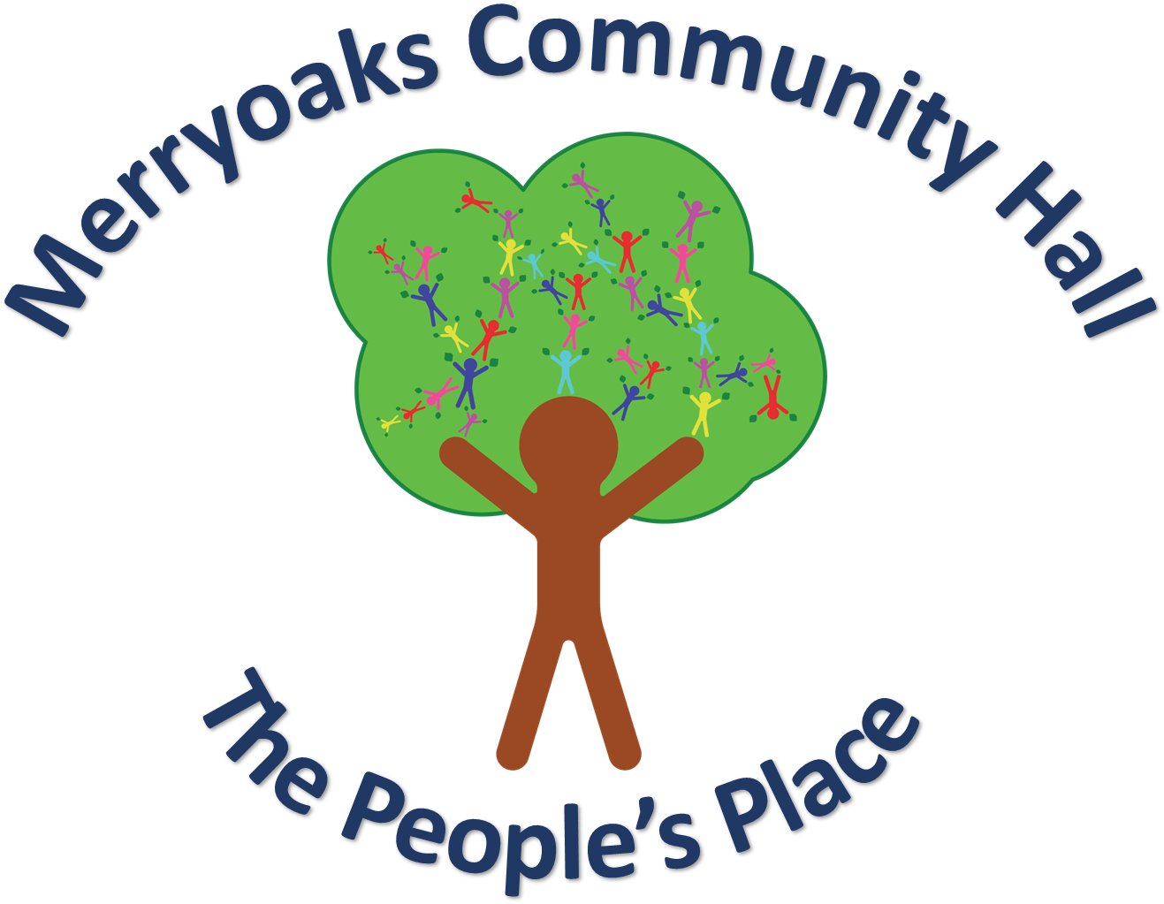

Lowes Barn Community Project AGM
4th February 2025 7:30pm
Merryoaks Community Hall

Agenda

7:00pm Doors open

7:30pm Meeting starts
- Apologies
- Minutes from the last AGM
- Questions

7:40pm Financial Statements
- Balance Sheet and Income & Expenditure
- Questions

7:50pm Election of Trustees

8:00pm Annual Reports - Introduction
- Governance
- Merryoaks Community Hall Operations
- Events Organisation and Community Fundraising
- Grant Applications
- Garden
- Volunteer Management and Recruitment
- Community and Stakeholder Engagement
- Building Management
- Building Snagging and Rectification

8:50pm Discussion and Questions

8:55pm Any Other Business

9:00pm Meeting Closes

